Sri Lanka Development Forum 2005
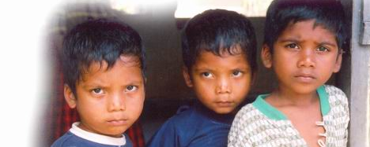
Civil Society Statement

The Government has convened the Sri Lanka Development Forum on 16th and 17th May 2005 in Kandy to discuss the ‘Rebuilding Sri Lanka: Post-Tsunami Action Plan’ that is supposed to be published on 15th May 2005. The World Bank, IMF, Asian Development Bank and all UN Agencies, as well as the Japanese, American, British and many other Bilateral Donors, will be present.

From the non-governmental sector, it is understood that the Consortium of Humanitarian Agencies, World Vision, Oxfam GB, Sewalanka and Sarvodaya have been invited to attend.

Two hundred people’s organisations present a united front

The organisations endorsing this statement represent fish worker collectives, farmer groups, women’s organisations, trade unions, plantation worker organisations, NGOs, human rights organisations, lawyers’ groups, academics, scientists, clergy and others from across the country. While we have not been invited to provide input to the Development Forum, we take this opportunity to present our collective position in the hope that this may open avenues for further dialogue. However, the current climate of repression of dissenting voices does not bode well.

We welcome the Government’s decision to take responsibility for the elaboration of an action plan for rebuilding after the tsunami and for the coordination of the numerous agencies involved. We also strongly support the guiding principles they have identified of responding to local needs and priorities, without discrimination, in a transparent and accountable manner, through consultation and the empowerment of communities and their organisations. However, we see that in practice almost the complete opposite is happening.

Serious problems with the current plans and processes

After nearly 5 months, hundreds of thousands of people affected by the tsunami are still living in the most desperate circumstances amidst complete uncertainty about their future. Relief is being dumped hurriedly, without proper consideration of their needs and desires or of the problems of poverty and in some cases conflict in which they were living even before the disaster. The affected people are being pushed into positions of passive, subservient receivers, who begin to compete with each other to get whatever possible, while the unaffected people, including many who have lived in displaced camps and suffered equal distress for up to 15 years because of the war are ignored.

Rebuilding policies are being imposed without dialogue. Decisions are being made by an extra-governmental body TAFREN composed entirely of big business leaders with vested interests in the tourist and construction industries, who are completely unable to represent the interests of the affected communities and who have no professional experience of dealing with disasters. Policies and plans developed by this body are not known by the affected people, and in many cases are not even known by the local government officials.

The action plan is hugely biased towards infrastructure construction, including highways, large ports and modern townships, under the banner of ‘fulfilling the dreams of a modern society’. Officials have also announced that they will be including their previous plans for infrastructure development in the country, including the Norochcholai Power Plant and the Upper Kotmale Dam. Almost no attention is given to how the affected people can rebuild their lives and livelihoods rather than just their physical assets. There are social, psychological, environmental and other problems that must also be addressed urgently.

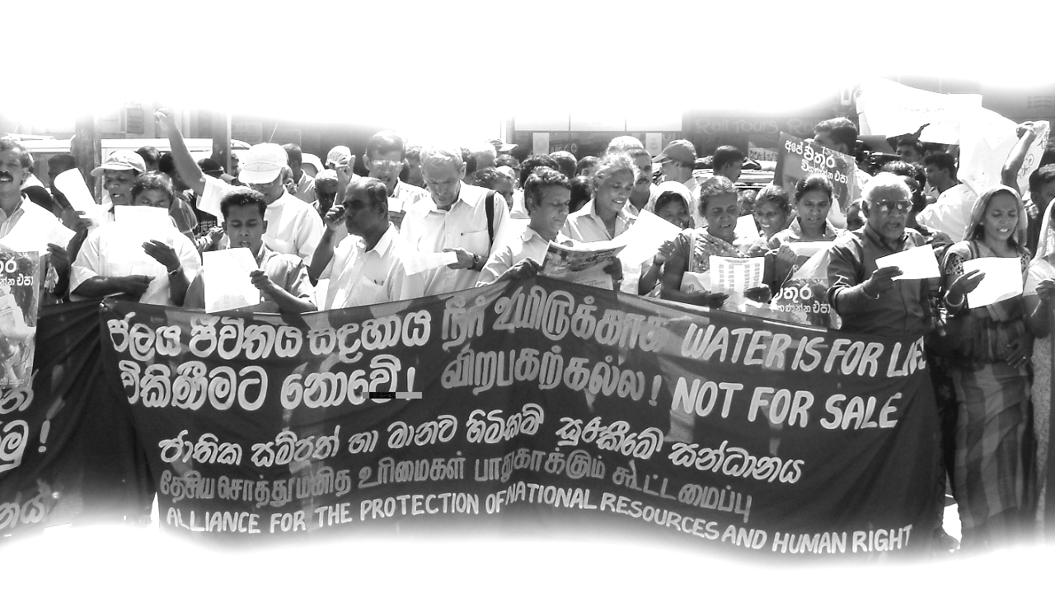
The plan is also being used to push through structural reforms in the national economy, including attempts to reduce labour protection, privatise electricity and water, and sell off other national resources such as the Eppawela Phosphate Deposit.

These old neo-liberal strategies for transforming the country into a haven for export-oriented business using the people’s money to build infrastructure for the businesses to use have been tried in Sri Lanka for three decades and have only served to further marginalise people by pushing them off their land and out of their livelihoods. The only export businesses that have survived here have been the tea plantations and the garment factories, both built on the basis of very poorly paid and badly treated, mostly women workers. This strategy has been strongly resisted by people in Sri Lanka for years and it was completely rejected by the people in the last election only a year ago.

Government must act to bring in the people

Given our very serious concerns, we ask that the Government take action to ensure that mechanisms are immediately established to put into practice the principles described above. The big business taskforce TAFREN must be disbanded and replaced with a people’s planning commission with representatives of all affected communities and their organisations, and with appropriate experts with experience of social, psychological and environmental as well as physical rehabilitation. The bill formally establishing TAFREN as an Authority to coordinate the development and implementation of rebuilding plans over the next 3 to 5 years, which it is reported is being discussed in Cabinet this week, must not be passed until these essential changes are made.

The Government must make accessible full information on the resources received and pledged for rebuilding, on the plans and policies agreed, and on the entitlements therefore due to the people in all government offices in Sinhala and Tamil. This must include full disclosure of the texts of all agreements between Government and donors and between Government and private contractors. The Government must ensure that all officials are fully aware and able to respond to enquiries from people. The Government must also establish an appropriate complaints procedure to address grievances that may arise.

The Government must abandon all attempts to restrict people’s rights of access to land. They should commission a survey by independent scientists to present proposals for the protection of people from possible future disasters. The Government’s decision to allow tourist hotels to remain on the beaches demonstrates that the solution need not be to move people away from the coast. Where resettlement is necessary, this must only be done after full consultation with the affected communities on the basis of full information about the real threats and the options available. The coast belongs to the fishing communities. Buffer Zones, Tourism Zones and High Security Zones that restrict their rights to access their lands and to pursue their livelihoods must be removed.
Donors must live up to their promises

We remind the Donors that the whole world is watching them. They must take responsibility for ensuring that the principles of participation that they espouse are actually put into practice, as they have now given massive loans and grants without any evidence of consultation with the people. They should support the Government in engaging in dialogue with the affected people and in establishing mechanisms for bringing the people into the planning and implementation of rebuilding work. They must take the initiative to disseminate the full details of the resources they are providing and the conditions under which they provide them, in Sinhala and Tamil.

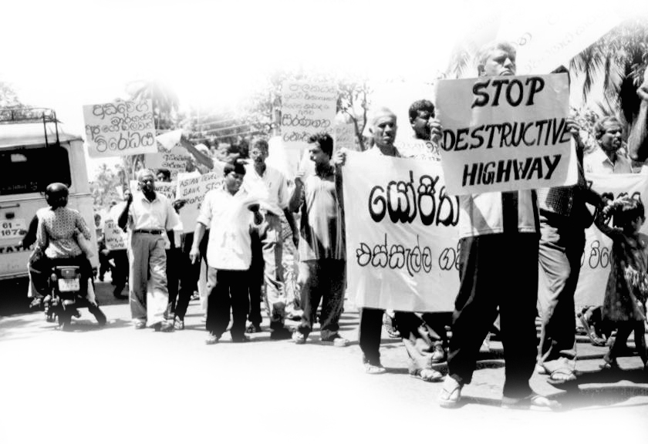
Where the Donors are responsible for infrastructure projects, they must pay heed to their previous experiences in Sri Lanka and the social and environmental problems
that have emerged from poorly planned projects.

They should reconsider offering loans at all in this
situation where the Government and the people of Sri Lanka are
already labouring under a huge debt burden, and where there are very few possibilities for generating the resources for paying these loans back, other than by taking yet more loans or by cutting back on essential social services.

International NGOs must set the example

We ask international NGOs to set an example for Government and Donors to follow. INGOs must take the responsibility to strengthen people and their organisations and bring them into both practical programmes and policy debates, recognising that they have unique knowledge and abilities that cannot be replaced by outsiders.

They should work with their supporters who have so generously contributed resources for the affected people, to help them to understand that short-term time targets for disbursing money and disregarding communities living in some cases only metres away in equally dire conditions are totally counterproductive and can actually lead to new conflicts. In particular, consideration must be given to the plight of the communities displaced by the war as well as those displaced by the tsunami.

INGOs must remember that their role is not simply to act as contractors, implementing Government or Donor policies and plans, but is also to hold Government and Donors accountable. They themselves must establish mechanisms for ensuring that they are accountable to the affected communities as well as to their supporters.

Call for a people’s process

We reaffirm our belief that the very serious problems that remain to be solved must and can only be addressed through a people’s process that recognises that all resources pledged in the name of the affected people genuinely belong to them and must be used in the way that they see fit.

We urge all parties to contact us for further discussions on how this could be implemented. Correspondence may be directed by email to monlar@sltnet.lk. Telephone enquiries may be made to 011 2865534 or 011 4407663.
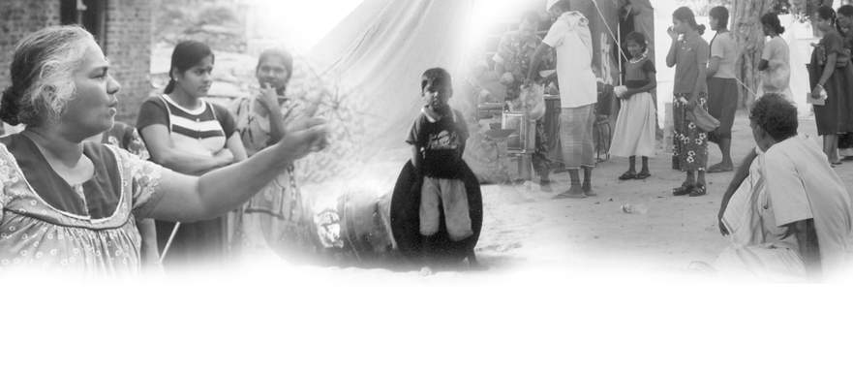

Signed by:

- Agricultural and Rural Workers’ Development Society, Nuwara Eliya
- Akuna Newspaper, Colombo
- All Ceylon Fishermen Union, Colombo
- All Ceylon United Workers’ Congress, Nawalapitiya
- Alliance for the Protection of National Resources and Human Rights, Colombo
- Ampara District Fisheries Solidarity, Ampara
- Anuradhapura District Farmers Assembly, Anuradhapura
- Arising Sun Community Development Organisation, Nuwara Eliya
- Arunodaye Parisarikayo, Gampaha
- Centre for Family Services, Kurunegala
- Centre for Social Concern, Hatton
- Centre for Society and Religion, Colombo
- Ceylon Plantation Workers’ Union, Hatton
- Civil Forum, Hatton
- Commercial and Industrial Workers Union, Colombo
- Community Development Centre, Colombo
- Community Education Centre, Malabe
- Community Resources Development Centre, Dambulla
- Cooperatives, Corporations and Mercantile Union, Colombo
- Christian Workers’ Fellowship, Hatton
- Dabindu Collective, Gampaha
- Democratic Leftist Front, Colombo
- Devasarana Development Centre, Kurunegala
- Diyasa Group, Colombo
- Eastern United Women’s Organisation, Trincomalee
- Education and Cultural Forum, Kurunegala
- Federation of Media Employees’ Trade Union, Colombo
- Franciscan Reverend Sisters, Polonnaruwa
- Free Media Movement, Colombo
- Free Trade Zone Workers’ Union, Colombo
- Gami Sevana, Kandy
- Gemi Kantha Peramuna, Gampaha
- Government Drivers’ Union, Colombo
- Government Office Workers’ Union, Colombo
- Government Printers’ Union, Colombo
- Government United Federation of Labour, Colombo
- Haraya Newspaper, Colombo
- Health Services United Telephone Operators’ Union, Colombo
- Hiru Group, Colombo
- Hiru Newspaper, Colombo
- Home for Human Rights, Colombo
- Human Development Institute, Kurunegala
- Human Development Organisation, Kandy
- Human Education Aid Relief Trust of Society, Nuwara Eliya
- Independent Cooperators Collective, Colombo
- INFORM, Colombo
- Institute of Social Development, Kandy
- Jaffna District Fisheries Cooperative Society, Jaffna
- Janawaboda Kendraya, Negombo
- Kalmunai Muslim Women’s Research and Action Forum, Kalmunai
- Kalutara District Farmers Assembly, Kalutara
- Kalutara District Fisheries Solidarity, Kalutara
- Kantha Diripayasa, Gampaha
- Kegalle District Women’s Cooperative Committee, Kegalle
- Kithudana Pubuduwa, Gampaha
- Kotagala Samuga Sevai Mandram, Nuwara Eliya
- Lanka Academic Forum, Colombo
- Lanka Teachers’ Society, Colombo
- Lawyers for Human Rights and Development, Colombo
- Leo Marga Ashram, Bandarawela
- Mathiyugam, Nuwara Eliya
- Manawa Himikam Payasa, Gampaha
- Mannar District Fisheries Cooperative Society, Mannar
- Matale District Farmers Assembly, Matale
- Matale District Savisthri Women’s Organisation, Matale
- Matara District Farmers Assembly, Matara
- Medical Laboratory Technicians’ Union, Colombo
- Moneragala District Farmers Assembly, Moneragala
- Movement for National Land and Agricultural Reform, Colombo
- Movement for the Defence of Democratic Rights, Colombo
- Movement for the Protection of Indigenous Seeds, Eppawela
- Movement to Empower Women in the Plantations, Bandarawela
- Muguna Development Foundation, Mahiyanganaya
- Muslim Women’s Research and Action Forum, Colombo
- Nachchaduwa Fisheries Cooperative Society, Anuradhapura
- Nandana Marasinghe Memorial Foundation, Colombo
- National Farmers’ Assembly, Colombo
- National Fisheries Solidarity, Negombo
- National Teachers’ Union, Colombo
- National Union of Workers, Hatton
- Navayuga Social Development Forum, Nuwara Eliya
- Nawamaga Foundation, Moratuwa
- Negombo Lagoon United Fisheries Organisation, Negombo
- New Leftist Movement, Colombo
- NGO Forum, Hatton
- Nirmani Centre, Gampaha
- Organisation for the Protection of Community Resources, Moneragala
- Organisation for the Protection of Human Resources and Environment, Hambantota
- Organisation for the Protection of Human Freedom and Environment, Mahiyanganaya
- Organisation for the Protection of Legal Services and Human Rights, Hambantota
- Parakrama Farmers’ Organisation, Mahiyanganaya
- Participatory Action and Learning Methodology, Nuwara Eliya
- Pasesa, Kandy
- Peasant Information Centre, Kurunegala
- Penn Wimosana Gnanodayam, Hatton
- People’s Cultural Collective, Negombo
- Plantation Rural Education and Development Organisation, Kandy
- Plantation Sector Social Forum, Kandy
- Plantation Women Development Foundation, Nuwara Eliya
- Plantation Workers’ Service Centre, Nuwara Eliya
- Praja Shakthi Development Foundation, Puttalam
- Praja Shakthi Forum, Puttalam
- Praja Vimukthi Forum, Kurunegala
- Progress Union, Colombo
- Prosperity of Workers Employed in Rural Sector, Badulla
- Provincial Public Clerical Services Union, Colombo
- Pudiya Samadharmam, Colombo
- Puttalam District Farmers’ Assembly, Puttalam
- Puttalam District Fisheries Solidarity, Puttalam
- Railway Labourers’ Unity, Colombo
- Rajarata Jana Prabodnia Foundation, Anuradhapura
- Ravaya Newspaper, Colombo
- Rekawa Development Foundation, Hambantota
- Research Centre for Interethnic Peace, Colombo
- Ruhunu Community Development Centre,
- Ruhunu Rural Women’s Organisation, Hambantota
- Ruhunu Shakthi Organisation, Hambantota
- Rural Community Development Organisation, Anuradhapura
- Rural Women’s Organisation, Mahiyanganaya
- Ruwanpura Farmers’ Voice, Ratnapura
- Sarana Foundation, Hambantota
- Satyodaya, Kandy
- Savisthri, Colombo
- Shramabimani Centre, Negombo
- Social Economic Training Institute Kandy, Kandy
- Social Welfare Mandram, Nuwara Eliya
- Society for Welfare, Education and Awareness Training, Nuwara Eliya
- Southern Fisheries Organisation, Galle
- Southern Fisheries Organisation, Hambantota
- Southern Fisheries Organisation, Matara
- Sri Lanka Janaraja Health Services Union, Colombo
- Sri Lanka Jathika Peace Development Society, Badulla
- Sri Lanka Pugwash Group, Colombo
- Sri Lanka United Agro Society, Kalutara
- Sri Lanka Working Journalists’ Forum, Colombo
- Sri Vimukthi Women Fisheries Organisation, Negombo
- Suriya Women’s Development Centre, Batticaloa
- Third Eye Local Knowledge and Skills Activists Group, Batticaloa
- Thothenna, Puttalam
- Thulana, Kelaniya
- Trade Union Centre for the Right to Rebuild the Nation, Colombo
- Trincomalee District Fisheries Cooperative Society, Trincomalee
- Udapamunuwa Women’s Organisation, Moneragala
- United Federation of Labour, Colombo
- United Mine Workers’ Union, Colombo
- United Plantations, Dickoya
- United Plantation Action, Hatton
- United Socialist Party, Colombo
- United Welfare Organisation, Nawalapitiya
- Upcountry Workers’ Information Development Foundation, Nuwara Eliya
- Uva Community Development Centre, Badulla
- Uva Farmers’ Development Foundation, Badulla
- Uva Human Development Foundation, Badulla
- Uva Shakthi, Badulla
- Uva Wellassa Women Farmers’ Organisation, Moneragala
- Uwagewewa Beneficiaries Organisation, Hambantota
- Vanni Community Development Foundation, Vavuniya
- Vidhavi Cultural Centre, Colombo
- Vikalpanai Women’s Organisation, Colombo
- Vimukthi Media Forum, Colombo
- Wellassa Development Foundation, Moneragala
- Wilpotha Women’s Savings Scheme, Chilaw
- Women and Media Collective, Colombo
- Women’s Alliance for Peace and Democracy, Colombo
- Women’s Centre, Gampaha
- Women’s Development Foundation, Kurunegala
- Women’s Development Centre, Kandy
- Workers’ Development Centre, Nuwara Eliya
- Workers’ Development Society, Bandarawela
- X Group, Colombo
- Young Environmentalists’ Forum, Matara

Supported by:

- 50 Years Is Enough: U.S. Network for Global Economic Justice, USA
- Advancing Public Interest Trust, Bangladesh
- All Nepal National Free Students Union, Nepal
- All Nepal Women Association, Nepal
- Angikar, Bangladesh
- Bangladesh Krishok Federation, Bangladesh
- BanglaPraxis, Bangladesh
- Center for Economic Justice, South Africa
- Centre for Research and Action on Development, Bangladesh
- Coastal Development Partnership, Bangladesh
- Cooperazione e Sviluppo, Italy
- Coalition Jubilee 2000, Angola
- Europe External Policy Advisors, Belgium
- Focus on the Global South, India, Philippines, Thailand
- Food First/Institute for Food and Development Policy, USA
- Global Justice Ecology Project, USA
- Global Women’s Strike, International
- Hivos, Netherlands
- Hong Kong Polytechnic University, Hong Kong
- Intermediate Technology Development Group, South Asia
- International Movement Against all forms of Discrimination and Racism, International
- Jubilee Coalition, South Africa
- LOKOJ Institute, Bangladesh
- Marymount Manhattan College, USA
- Medico International, Germany
- Mindanao Interfaith People’s Conference, Philippines
- Missionary Oblates, USA
- National Alliance of People’s Movements, India
- New Voices on Globalization, USA
- National Fishworkers' Forum, India
- Oakland Institute, USA
- One Vote Per Person, USA
- Pax Christi / National Catholic Peace Movement, USA
- Reality of Aid - Asia Pacific, Philippines
- Roots for Equity, Pakistan
- Samajwadi Jana Parishad / People’s Socialist Party, India
- School of Oriental and African Studies, UK
- Second Chance Foundation, USA
- Solidarity Africa Network in Action, Kenya
- Solomon Asch Center for Study of Ethnopolitical Conflict, USA
- South Asia Alliance for Poverty Eradication, International
- Suburban Philadelphia Greens, USA
- Voice of Dalit International, UK
- Women’s Welfare Society, Nepal
- World Forum of Fisher People, International
- XminusY Solidarity Fund, Netherlands

While we repeat the widely-used term ‘Donor’, most should rather be called ‘Lenders’.

